

**Faculty of engineering - Shoubra**

**Benha University**

|  |  |  |  |
| --- | --- | --- | --- |
|  | Name | Edu mail | B.N |
| 1 | **حبيبة هاني محمد عزت** | habiba195308@feng.bu.edu.eg | **279** |

**TOBIC:**

Computer architecture

* **Application Brief:**

Computer architecture deals with the design of computers, data storage devices, and networking components that store and run programs, transmit data, and drive interactions between computers, across networks, and with users. Computer architects use parallelism and various strategies for memory organization to design computing systems with very high performance. Computer architecture requires strong communication between computer scientists and computer engineers, since they both focus fundamentally on hardware design. We can say that computer architecture is future.

* **Screen shots:**

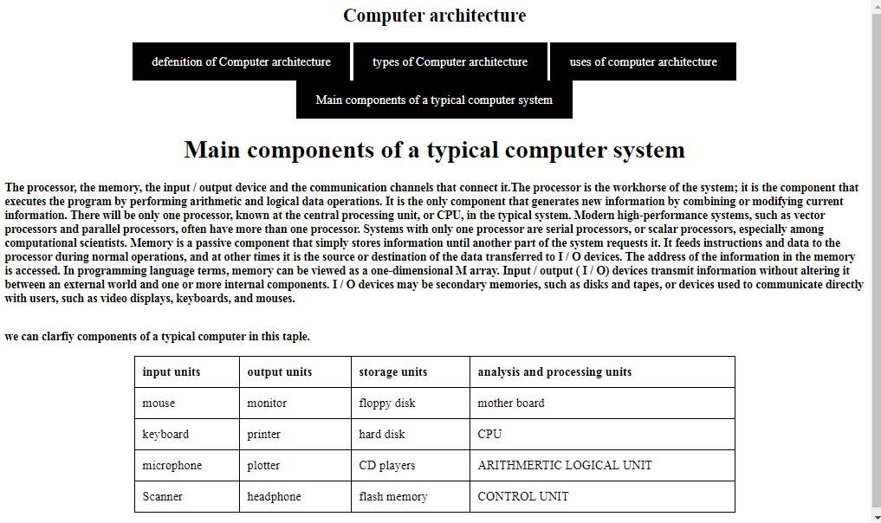

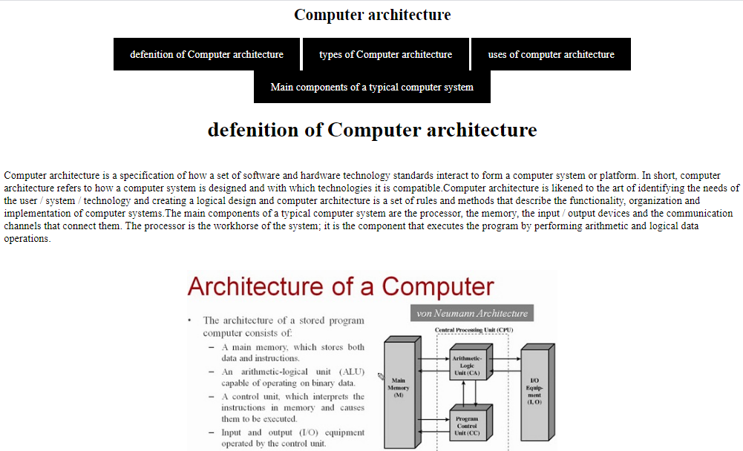

* **Source code:**

